SKU: AG-VACUUM/RB
Regenerative Blower Vacuum Pump Connection

Connect as this, remember use thread tape to avoid leaking:
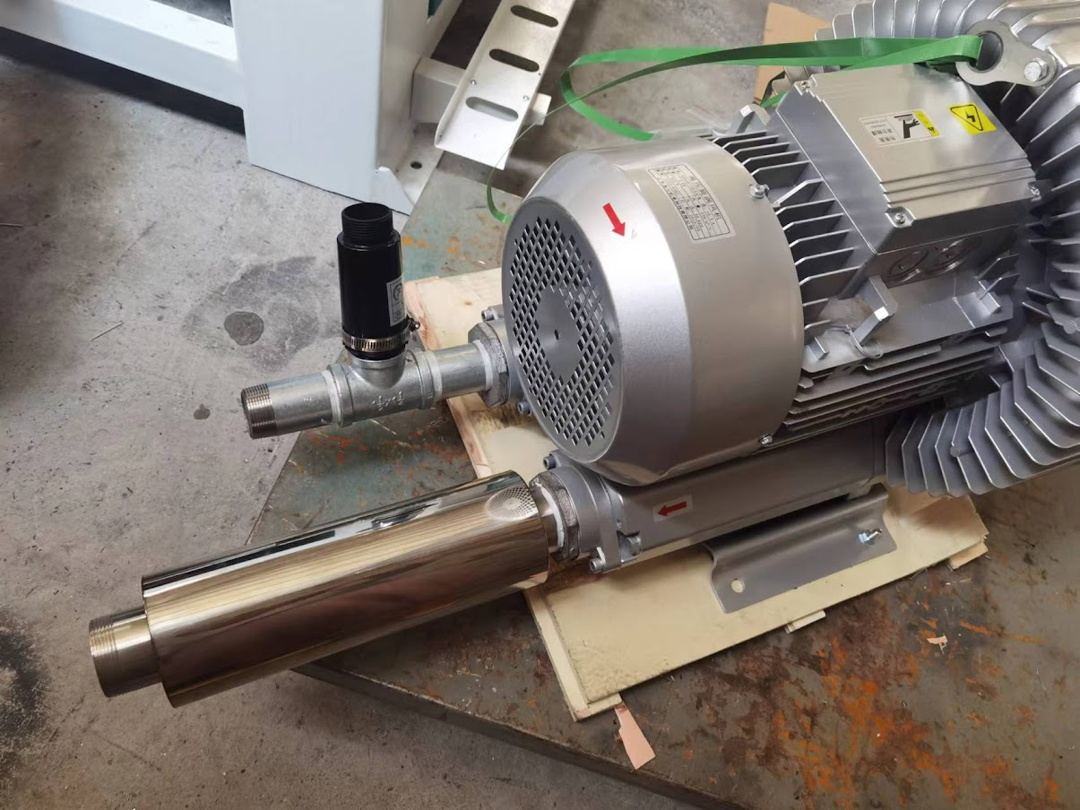
Vacuum Hose NOT Included, SKU: AG-VACUUM/45
